Shabbos Stories for
Parshas korach 5775
Volume 6, Issue 41 3 Tammuz 5775/ June 20, 2015
Printed L’illuy nishmas Nechama bas R’ Noach, a”h

For a free subscription, please forward your request to keren18@juno.com

Shabbos Treasures - The Precious Gift of Shabbos

The Family that Lived in a Coal Cellar Because of Keeping Shabbos

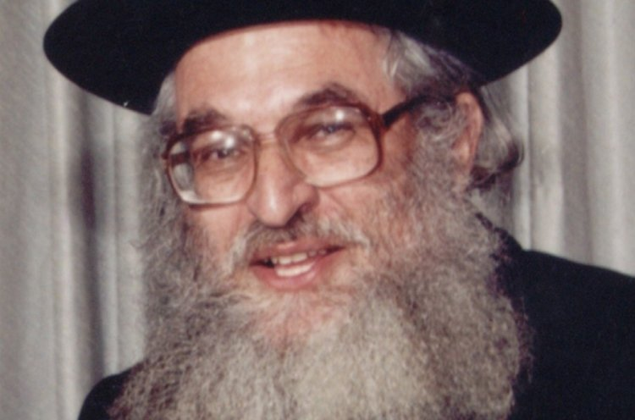
Rav Shimshon Pincus

Rav Shimshon Pincus relates a story about Shabbos that he heard personally from the grandson of the one it happened to. In the early 1900’s, a young immigrant Jewish family were being evicted from their home as they were not able to afford the rent. The father refused to go to work on Shabbos and he had lost job after job, and finally, his reputation had gotten ahead of him, and he was not able to get a job at all.
It was in the middle of a bitter cold winter in New York when the family was kicked out onto the streets. When the landlord saw the falling snow and the children walking out with no place to go, his mercy was aroused on them and he allowed them to remain in the coal cellar of the building, until they could find a place with a proper roof.

A Wealthy Jew Walks Down Their Street
A few weeks later, a wealthy Jew was walking down their street and was surprised to see two little boys with black skin playing in the street and speaking Yiddish! He said to his friend how he had never seen this before, and the boys explained to him that they were Jewish and in reality had white skin.
In astonishment, the wealthy Jew asked them why they were so dark, and the boys innocently told him it was because they live in a coal cellar. The wealthy Jew asked them if he could meet their father, and when asked about his living conditions, the father explained that he couldn’t hold a job because he refused to work on Shabbos.
Immediately, the wealthy man pulled out his check book and wrote the family a check for $500 (an enormous amount of money at that time), and handed it to the father.

“Do You Keep Shabbos?”
Now the father was shocked, but he looked at the check and asked the wealthy Jew, “Do you keep Shabbos?”
The man answered that he didn’t.
The father then said, “I have never violated Shabbos, and by taking your money, I feel like I will be sharing in your violation of Shabbos, and I am not willing to do that. However, since we are in a desperate situation, I feel it only right to first ask my wife what she wishes I do.”
He went inside to his wife and showed her the check, and explained to her how he felt about taking the money. His wife agreed with him, and the father returned the check to the shocked wealthy man.
When the wealthy man got home, he told his wife what had happened, expressing that he couldn’t believe that a family living in a coal cellar would refuse his gift of $500.

The Wife of the Wealthy
Jew Begins to Cry
When his wife heard their reason for turning down the money, she sat down and began to cry. Through tears she reminded her husband that when they came to America they also tried to keep Shabbos, but it was too difficult for them. She reminded him that they had agreed that he would begin to work on Shabbos just to get by, but that was never enough, and now they were so wealthy through Chilul Shabbos that even another Jewish family wouldn’t touch their money!
At the strong realization of his wife’s powerful words, the two of them resolved to keep every Shabbos from that day on. Together, they walked back and found the poor family who were in the coal cellar, and explained to them their new resolution and commitment to Shabbos. They invited the poor family to move in with them, and eventually, the two families became close friends. The wealthy man never violated Shabbos again, and he had children and grandchildren who remained committed to keeping Shabbos!

Reprinted from the Parshas Be’haalasocha edition of “Torah U’Tefilah: A Collection of Inspiring Insights” compiled by Rabbi Yehuda Winzelberg.

Making a Minyan in Paterson [New Jersey]
By Larry Yudelson

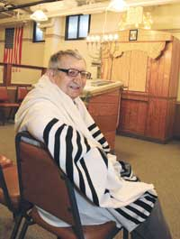

Vladamir Neplodnik, a resident of Paterson’s Federation Apartments, in the building’s synagogue.

Every other Shabbat, Jerry Schranz crosses the Passaic River to keep the final echo of Paterson’s once-storied Jewish community alive.
It’s a one and three quarters mile walk from his Fair Lawn home to East 27th Street, in what 50 years ago was the center of Paterson’s Jewish life. East 27th Street was the sensible place for the Jewish Federation of North Jersey to build housing for seniors: It was three blocks away from Barnert Temple and half a mile from the Barnet Hospital — both named for the Jewish industrialist and philanthropist who was Paterson’s mayor from 1889 to 1890. And it was across the street from the Yavneh Academy, Paterson’s Jewish day school.
Today, Barnert Temple, founded in 1847, is an empty shell; the Reform congregation moved elsewhere in Paterson in 1964 before decamping to Franklin Lakes in the 1980s. Yavneh moved to Paramus in 1981; the building is now home to the Rosa Parks High School of Performing Arts.
The Federation Apartments, however, continues to be home to dozens of elderly Jews. Sandy Eckstein, the building’s director, estimates that 40 percent of the 158 residents are Jewish. All but a handful of the tenants are subsidized by federal Section 8 vouchers; they must be at least 62 years old, and they must qualify as low income. The Jews in the building are from a different generation than those who moved in when the building opened in 1972; rather than coming from Paterson, all but eight of them were born in the former Soviet Union. This is because of Paterson’s proximity to Fair Lawn, which became the center for North Jersey’s resettlement of Soviet Jews beginning in the 1970s. It is not an assisted living facility — there is no nurse on staff — but many residents are in their 90s, and they have aides to help them with some daily tasks.

Russian Prayer Books in
The Basement Synagogue
Signs in the building are in three languages — English, Spanish, and Russian. And in the basement synagogue, across from the boiler room, Russian-language prayer books fill the shelves, and a Russian-labeled map of Israel is affixed to a pillar.
Russians are not known to be the most ardent of synagogue-goers; generations of official Soviet atheism took its toll. Yet there is a hardcore group of seniors in the Federation Apartments who attend services. Most of the half dozen are from the former Soviet Union. They are dependent on a small contingent of outsiders from Fair Lawn, like Mr. Schranz, to help make the minyan, and on paid Torah readers. These days, the minyan has a reader twice a month, so that is how often it meets.
The seniors who attend the minyan are enthusiastic as they show a visitor their synagogue.
“I like this synagogue,” Vladamir Neplodnik said. He came to the Federation Apartments from New York. Before that he lived in Moscow; he was born in the northern Caucasus.
“I like all synagogues,” he adds.
In general, expenses for the synagogue — in particular, hiring the Torah reader — are split between the Federation Apartments and the synagogue’s own account. The synagogue charges membership for High Holy Day services, when there is a larger turnout. Dues are $10. Members also contribute $10 for Yizkor. The synagogue’s electricity and heat are part of the general building expenses; the building’s custodian turns out the lights after services and disposes of the garbage from the kiddush.
Isak Meryam is in charge of the minyan in the Apartments. On Fridays, he’ll call to make sure people are coming. He opens up the synagogue on Shabbat mornings at 8 a.m., an hour before services begins. He leads the beginning of the service. He sets up the table where a kiddush of herring and shnapps will be served after services. And finally, he cleans up.
Mr. Meryam speaks pretty good English — it is one of his five languages. He is from Latvia. He was wounded in the Latvian army, where he met Roza, a nurse he soon married. That was 63 years ago. “Baruch Hashem, she is looking very nice,” he says. Roza is one of the two women who attend services regularly. (Holidays bring more women to the women’s section.)

The One American-Born Minyan Regular
Charles Lehmann is the one American-born resident who is a minyan regular. He grew up in New York City and lived in a number of places before moving to New Jersey in 1990. He has been in the Federation Apartments for a little over three years. And in that time, “I’ve been here for every service,” he said.
Before this, he was not a regular synagogue-goer.
“One of the reasons I moved into the building was to try to get some religious education,” he said. “Growing up I was not raised religious. My parents were of two different religions.”
Mr. Schranz originally was recruited for the Apartments minyan by a member of his softball team. “I didn’t know where Paterson was,” Mr. Schranz recalled. “It was about a 45 minute walk for me.”
He became a regular.

“Everybody Gets Involved”
“Everybody gets involved. That’s the essence of the shul,” he said.
A fellow Fair Lawn resident, Sam Heller, coordinates the minyan, arranging for the Torah reader and making sure that enough men will arrive to make a minyan. (The synagogue is Orthodox, as are most of the outsiders who attend.)
Now, though, four decades of low-budget no-rabbi synagogue maintenance have caught up with the synagogue.
“We were worried the Torah was going to fall apart in our hands,” Mr. Schranz said. The Yavneh Academy donated the two Torah scrolls in the late 70s. Now, the seams were coming unsewn, the handles were falling apart, and letters were fading. Even the belt holding the scrolls was going slack.
It was time for repairs.
In the spirit of the minyan, Mr. Schranz jumped in and found a scribe in Fair Lawn who could make the necessary repairs.
The expected price tag: $3,600.
Ms. Eckstein said the building would put up the money. The Torah scrolls were given to the scribe. Anshei Lubavitch in Fair Lawn lent a Torah for the minyan to use in the meantime.

A Connection with the
Jewish Paterson Diaspora
Mr. Schranz, though, would like the broader community to contribute to the repair project. He sees his call to support the minyan as a way of connecting people scattered by the Paterson diaspora — the Jews of Fair Lawn and Wayne and Franklin Lakes and elsewhere who left Paterson, or whose parents left Paterson.
He also looked into the history of the two Torah scrolls. One was donated by the Sussman family in 1953. He tracked down the 99-year-old daughter of the donor, and discovered that her grandson, Chaim Sussman — the donor’s great grandson — teaches at Yavneh.
Beyond the Torah repair, Mr. Schranz would love to have money to buy new prayer books. “I think the chairs could probably need an upgrade,” he said. “You have elderly people sitting on chairs without armrests.”

Reprinted from the May 8, 2015 edition of the New Jersey Jewish Standard.

Challahs from Heaven
Babylonian Talmud, Taanit 24b–25a

Rabbi Chanina ben Dosa was so poor that he and his wife often had nothing to cook for Shabbat. Every Friday, before Shabbat, she would throw a burning coal into the oven, so that smoke would drift out of her chimney and the neighbors would assume that she had what to cook.
A nasty neighbor said, “I know that that they don’t have anything. Let me go and see what all that smoke is about.”
When she knocked on their door, Rabbi Chanina ben Dosa’s wife was mortified and went to hide in an inner room. The nosy neighbor entered anyway. A miracle occurred, and she found the oven full of loaves of bread and a mixing bowl full of dough.
She called, “Come! Come! Bring the spatula. Your bread is starting to burn, and you need to get it out quick!”
Rabbi Chanina ben Dosa’s wife said, “That’s what I went into the inner room for.”
Indeed, the sages say, she was telling the truth. She was so accustomed to miracles that she wasn’t surprised that coals had turned into bread.
Later, Rabbi Chanina’s wife asked him, “How long will we have to suffer like this?”
“What should we do?” he replied.

The Wife’s Advice
She said, “Pray that we be given something of value.”
He prayed, and a hand-like apparition stretched down from the heavens and gave him a golden table leg.
He later dreamed that he saw all the righteous people in the world to comeeating at three-legged tables, while he and his wife were eating at a table with just two legs.
He asked his wife, “Will it be okay with you if all the other righteous people are eating at three-legged tables, while you and I are eating at a table that’s missing one of its legs?”
“What should we do?” she asked. “Pray that it should be taken from you.”
He prayed, and it was taken from him.
The sages remarked that the second miracle was greater than the first, because tradition says that the heavens give but they don’t take back.

Reprinted from last week’s email of Chabad.Org Magazine.

Howard Stern’s Daughter Became Orthodox & Wells of Miriam
By Allison Josephs

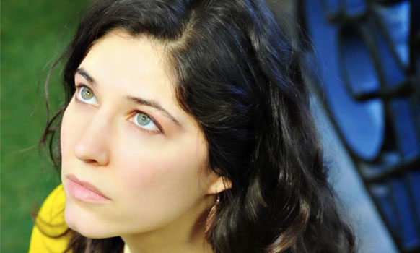

Like most people on planet earth, I’ve known who Howard Stern is for years, though, I’ve never really listened to his show or watched more than an occasional clip of “America’s Got Talent.” Then my friend Mayim Bialik was interviewed on his radio show last year and, of course, I had to hear it. What struck me most about their conversation was Mayim explaining Jewish ideas to Howard – like mikvah and modesty – publicizing these mitzvos to millions of his listeners.
Howard challenged Mayim, wanting to know why she covers up so much – unlike most actresses in Hollywood – and Mayim explained that her body belongs to her, not Hollywood. Apparently, Howard was so struck by this idea that the next morning when he started his show he referenced it.
Howard Stern didn’t cross my mind again until a couple months ago, when I stumbled upon a poet whose work is featured in the LA Jewish Journal. A line in one of her poems jumped out at me “Why in the world why in the heavens when God says find a mate, Adam never stops to say, You, G-d. Us. ”
It was so profound, I wanted to hear more. So I started clicking through to read more of her work and as I read, I got to an article which explained who her dad was. I was fascinated! Howard Stern’s daughter became an Orthodox Jew?! I reached out to her, we had a wonderful coffee meeting and told her I’d love to share her story and her art with the world.
Emily grew up Reform and “really did love it.” She sang in the choir, was close with the cantor, and always felt a connection with Judasim. But the ritual element was always missing. In her search to find a community that resonated with her, she stumbled upon Orthodoxy. She started out in the theater community majoring in theater at NYU, then at the age of 23, she randomly walked into a havdalah ceremony, hosted by the organization Romemu, in a yoga studio one Saturday evening.

“Mikvah hatikvah: water retention landscape” from “The Wells of Miriam” by Emily Stern. Portugal 2014.

She had never seen a ritual that related to the world in such a grounded way. After that night in the yoga studio she found two ways of expressing her soul in the world authentically: by relating to matter through halacha, and infusing Judaism into her art. Inspired by the language of Torah, and wanting her writing to speak the same language, Emily joined an art fellowship at Drisha Institue (a seminary for Jewish education on the Upper West Side) and wrote a play there. While at Drisha she was lead to study at Nishmat, which is a center for advanced Torah study for women, in Israel.
Growing up on Long Island, Emily did not have much of an impression or interaction with Orthodox Jews. She always recognized a special light in the religious Jews she saw from afar. Seeing something as simple as a man wearing tzitzis always seemed holy to her. While becoming more observant, she thankfully was not met with too much pushback from her family and friends and found that most of them appreciated her journey. Perhaps the one exception was the first time her mother came to Israel and saw her praying; she expressed a fear about losing her daughter. Other than that, Emily says it was such a visible “emergence of her truth,” that her family could appreciate the changes she was making, which she was careful to make slowly.
Emily is passionate about exploring and publicizing Torah to the world through art. Creating art has always been a spiritual experience for her. It began in her childhood, when she found herself praying to calm her nerves before taking to the stage. Nowadays the spirtuality in her art manifests itself in more of a “constant conversation with the world and life itself.” Emily said that she’ll open to a piece of Torah at random and find that it fits with an exact character she’s writing or theme of one of her poems.
She has produced several different types of art, including an album called “Birth Day,” which she describes as “the nature of divinity and the divinity of nature.” She has also written “Love Psalms” which are short devotional poems to God. After finding Torah at Drisha and Nishmat she went on to write a children’s song book based on Perek Shira. The book is called The World is a Song So Come and Play, and in it children discover their song like each of the animals and their unique praises of God in Perek Shira. Her latest venture is a photography project called “The Wells of Miriam.”
The name of the project comes from the well that accompanied the Israelites in the desert, and provided them with water in Miriam’s merit. The project started when Emily first saw a water retention landscape (pictured below)– a sustainable form of water management –in Portugal in 2014. Water retention landscapes are created to “reverse desertification” and “look like paradise.”
They are ditches dug in intelligent ways to model a pond or lake, and help with altitude and water circulation. They are made entirely of natural materials and when there is rainfall the water fills deeply into the earth and rehydrates the land. New vegetation grows, new animals come and new ecosystems form, in formerly barren wasteland.
The final (and most fascinating) step is when the ditch is full to capacity…and becomes a mikvah. The retention landscapes are mikvaot (!) because they are entirely filled with rainwater. When Emily made this connection, she knew she wanted to explore the topic through photography. How apropos that a renewable, sustainable water source, is also a mikvah, the bastion of monthly renewal for Jewish couples. Just as these new waters renew and replenish an arid desert, so too the mikvah gives us a chance to renew our relationships and renews the possibility to bring new life to the world. Emily ended our interview by explaining one of her favorite parts of the Torah was where Hashem is called “Mikvah Yisrael,” the Hope/Renewer of Israel.”

Reprinted from the June 11, 2015 website of Jew in the City. Thanks to my good friend Mordechai Etengoff for bringing the above article to my attention.

Divine Intervention Is a Hope, Not a Horse, in the Belmont
By Billy Witz

(Editor’s Note: The following article was written before the running of the Belmont Stakes, the last event in horseracing’s fabled Triple Crown. The jockey Victor Espinoza and the horse owned by Ahmed Zayat, an Orthodox Jew went on to win in Belmont and sweep the Triple Crown this year.)

Just a few dozen furlongs from Belmont Park lies the grave site of Rabbi Menachem Mendel Schneerson, the rebbe of the Lubavitcher group of Hasidic Jews. Since Schneerson died in 1994, Jews from all over the world have made a pilgrimage to Montefiore Cemetery to pay homage to the charismatic rebbe.
Many visitors write notes on small pieces of paper and toss them onto his grave, believing that the rebbe will deliver the messages to G-d.
On Thursday, Schneerson’s grave had an unusual visitor.
Victor Espinoza, who was trying to win horse racing’s revered Triple Crown aboard American Pharoah on Saturday, paid his respects. Espinoza is not Jewish. He does not consider himself religious, either.
Espinoza said he made his visit at the behest of a friend, whom he declined to identify but said was not Ahmed Zayat, American Pharoah’s owner, who has donated heavily to Orthodox Jewish causes.
“I was just curious,” Espinoza said Friday outside the jockey room. “To me, life is all about learning.”

If there is someone who might appreciate the value of learning — as well as any help from a higher power — it is Espinoza. This was his third crack at winning the Triple Crown, something he was unable to do aboard War Emblem in 2002 and California Chrome last year.
Each step of the Triple Crown brings a greater sense of ecstasy, attention and scrutiny — making the disappointment of falling short all the heavier.

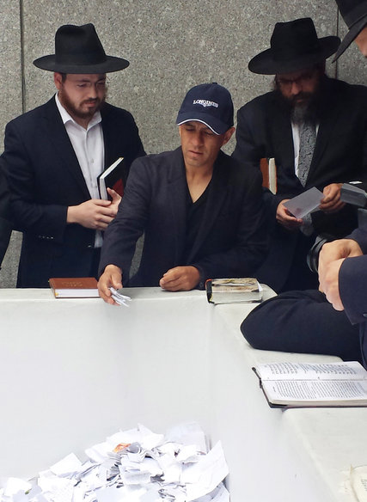
Espinoza, who was to ride American Pharoah, left a note at the grave of a rabbi who is said to have G-d’s ear.(Photo Credit Kevin Tun, via Associated Press)
“I learned the most important thing — not to lose,” Espinoza said. “The other two times, I felt like a loser. Hopefully, this time is different.”
Since Affirmed won the Triple Crown in 1978, 14 horses have swept the first two legs, the Kentucky Derby and the Preakness. Espinoza, who races mostly on the West Coast, does not have an enviable record at Belmont. Entering Friday, he had won just four of 73 races, according to Equibase. He was scheduled to run two races Friday.
“It’s a lot of pressure, but if I was in his position, that’s a good pressure,” said the jockey Joel Rosario, who won the 2013 Kentucky Derby aboard Orb but finished fourth in the Preakness and third in the Belmont. “To have a horse that wins the Kentucky Derby, then the Preakness and then he has a good chance to win the Belmont? That doesn’t happen every day.”
Zayat said he was certain he had the right jockey.
“He has ridden the horse before with confidence,” said Zayat, whose horse is trained by Bob Baffert. “He’s ridden brilliantly. Since he’s gotten on the horse, he’s been undefeated, so I have a lot of confidence in him. It seems like he’s peaking and maturing as a jock.”

Victor Espinoza riding American Pharoah to victory at Belmont to win the first Triple Crown in horse racing since 1978. (Photo by Chang W. Lee/New York Times)

“Be Safe and Make History”
Asked if he would have a message for Espinoza, Zayat said, “Be safe and make history.”
Rosario was to ride Frosted, who was a 5-1 bet — second to American sPharoah (3-5) — and was well rested, skipping the Preakness after placing fourth in the Kentucky Derby. Rosario called the Preakness, which American Pharoah won handily, a one-horse race but said the mile-and-a-half Belmont was a different race, longer than anyone had run before.
Rosario smiled when he was asked if he was prepared to be the villain.
“Well, we want to see the Triple Crown, but we want to win,” Rosario said.
John Velazquez, who was to ride another contender, Materiality (6-1), said the length of the Belmont made it more unpredictable.
“None of these horses have run one and a half miles,” Velazquez said. “No one knows until they run it how they’re going to do. You have to be really patient.”
That’s a task often made simpler with a small field. Only eight horses were entered. But as history would suggest, it often takes a perfect confluence of events for a horse to win the Triple Crown. Not many have even come close.
“You can’t win a race like this and make history and try to do something that hasn’t been done in 37 years unless everything goes right,” Zayat said. “You have to have the right trainer, the right jock, the right horse, the right everything.”
Which perhaps explains why Espinoza took some time last week to ask for a little help from above.

Reprinted from the June 6, 2015 edition of The New York Times.

The Incredible History of a Greek Jewish Shul in NYC
By Marjorie Ingall

A festive trip to Congregation Kehila Kedosha Janina, the only Romaniote synagogue in the Western Hemisphere

This past Sunday, strings of Greek, Israeli and American flags danced in the breeze over a Lower East Side block. The air smelled of honey. Long lines of people waited to nosh on baklava and biscochos, a traditional Sephardic cookie. Under a big banner reading YASOU! a diverse crowd of Jews, Latinos, Chinese-Americans—along with the typical mix of white-sneaker-wearing tourists and local hipsters with expensive haircuts—listened to live bands rocking out with ouds and daoulis. (I especially enjoyed the awesomely-named Pontic Firebird, which plays dance music from the western Pontic zone of the Black Sea.)
The Greek Jewish festival was sponsored by Kehila Kedosha Janina, a tiny synagogue on Broome Street between Eldridge and Allen Streets. I’d passed it many times—it’s only a few blocks from my apartment—assuming that it was one of the many small shuls in the neighborhood that had become fancy condos. But no: Kehila Kedosha Janina is the only Romaniote synagogue in the Western Hemisphere.

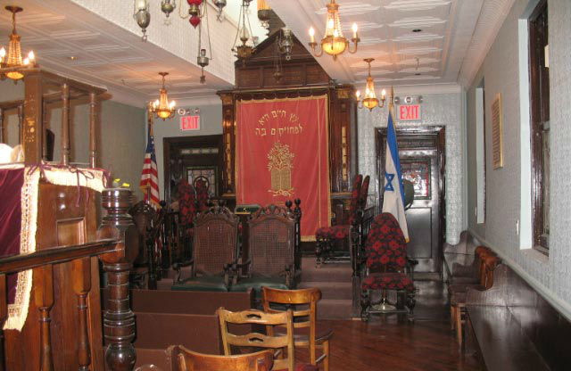
(Kehila Kedosha Janina)

The Romaniotes are a people who view themselves as neither Ashkenazi nor Sephardi. According to their oral tradition, they’re descended from Jews who were put on a slave ship to Rome after the destruction of the Second Temple in Jerusalem in 70 CE; a storm grounded the ship in Greece, and there they stayed for 2000 years. Their unique culture flowered. They didn’t speak Ladino, the Spanish-Hebrew hybrid language of Sephardic Jewry; they spoke their own Judeo-Greek language, sometimes called Yevanic—a mix of Greek, Hebrew and Turkish with a few Spanish words thrown in.
The Romaniotes were acculturated people, living peacefully among their non-Jewish neighbors while retaining their own traditions. Then, during the Middle Ages, Jews fleeing persecution in Italy, France and Germany made their way to Greece as well, and after 1492, they were joined by Sephardic Jews who’d been expelled from Spain. Many Romaniote communities were absorbed into the broader, wealthier Sephardic culture. But Jews in the isolated town of Janina (or Ionnina), near Greece’s Albanian border, kept their Romaniote heritage alive.
These Jews wound up founding Kehila Kedosha Janina. They began arriving in New York shortly before the turn of the 20th century, during that period of American history when so many Jewish immigrants converged on the Lower East Side. They founded their congregation in 1906 and built the shul in 1927. They wanted a place of worship of their own—most of the other Jews on the Lower East Side were suspicious of them, doubting their Jewishness because they looked different and spoke no Yiddish.
Today, the building is a New York City historic landmark. Like most Sephardic shuls, it has a central pulpit with benches surrounding it. It has lovely stained glass windows and several vintage Greek Torahs, including one of only three extant Torahs written in Romaniote script. All over the walls and in cases around the women’s section in the balcony are artifacts from the old world: faded photos of Janina’s former residents, lavish robes, silver-encased megillah scrolls, a pair of beautifully carved and inlaid wooden platform sandals that women wore to the mikvah.
There’s also a collection of intricately calligraphed Alefs, hand-painted Romaniote amulets given to baby boys at their brit milah. Covered in the names of the forefathers, as well as the child’s father and grandfather, Alefs, adorned with illustrations and mystical writing, served as both a historical document and a symbol of protection from the evil eye. “The Alef hangs over the baby’s cradle for 40 days to protect him,” Marcia Haddad Ikonomopoulos, thedirector of the shul’s museum (as well as the President of The Association of Friends of Greek Jewry), told me in an interview. “It’s a Kabbalistic thing. The only other communities who had the Alef were close to Janina.”
Many families in Janina were poor, and women’s names in the town sometimes reflected parents’ desire for a boy. Boys, obviously, didn’t require dowries. In a fascinating piece for the synagogue’s newsletter, Ikonomopoulos lists some of the women’s names: “Perna” (from the Greek “pernas”—to pass) was a name for a girl with older sisters; her parents were literally praying for the curse of daughters to pass. “Stemma” (from the Greek “stamata”—to stop) was a prayer for the plague of daughters to stop.
Ikonomopolus noted, “One of the members of our congregation with the name of Stemma [survived] because, as the last of many daughters in a poor home, her family sent her to the United States in the 1930s with a cousin, hoping that here where a dowry was not a requirement, they would be able to marry her off. The rest of her family, including all her older sisters with their husbands and children, would perish in the Holocaust.”
Looking at the embroidery patterns and fezzes throughout the building, you can see the Turkish influence on Janina’s artifacts. Janina was conquered by Ottoman Turks in 1430 and remained under Turkish rule for nearly 500 years. This meant that Turkish foods, design, and words were joined with Jewish and Greek elements in the vernacular. Ikonomopoulos described some of the new surnames that cropped up during this period: “Hadjis” (from Turkish “hadj,” someone who had made a pilgrimage—in this case, for Jews—to Jerusalem), and “Hadjopoulos,” with the Greek ending “poulos,” meaning “son of,” or the son of someone who made a hadj. These names reflect Greekness, Turkishness and Jewishness all at once.
Unfortunately, acculturation ultimately didn’t protect the Jews of Janina. Nearly 90% of Greek Jews died in the Holocaust, the largest percentage of any European country in WWII. Today, Greece suffers from growing anti-Semitism that plagues much of Europe.
But the members of Kehila Kedosha Janina still feel a connection to their homeland. As Ikonomopoulos told me, “I never have met any Ashkenazim who described themselves Polish or Russian. But we’re proud to be Jewish, American and Greek. We have no trouble wearing all three hats. Our congregation goes on tours of Janina, and the ages of people on the tours range from 19 to 83. It’s so different from the Ashkenazi world. How many of you guys go home? And if you do, you say, ‘Thank God we got out!’ But we go back to visit, to celebrate Bar Mitzvahs. When we arrive, our eyes well up with tears. It’s a multi-tissue event.”
She concluded, “I’d like the world to know how very special this community is. It’s absorbed the true essence of Judaism—knowing who we are and passing it on to our children and grandchildren. We’ve preserved this older world and still take advantage of the wider world.”

Reprinted from the June 4, 2015 email of Tablet Magazine.

A Scientific Kiddush Hashem

At a convention of neurologists from all over the world, one of the speaker’s main topic was the phenomenon of people fainting upon getting up from bed in the morning. Professor Linda McMaron of Great Britain gave a lengthy speech regarding her study on this issue.
She elaborated that after many years of investigation on this subject, she came to the conclusion that such fainting is caused by the quick change of position from lying down to standing up.
Professor McMaron said that it takes 12 seconds for the blood to flow from the feet to the brain. But when a person quickly stands up when they get out of bed, the blood gets ‘thrown’ to the brain too quickly and this results in fainting.
Her suggestion was that each person, even one that does not have a tendency to faint, when they wake up, should first lay in bed and count slowly to 12, in order to avoid dizziness, weakness, and fainting. When she finished her speech, there was loud applause and enthusiastic feedback.
The next speaker was a religious Jewish professor, and before he began to speak about his topic, said that he would like to first comment about the preceding speech. He said, “By the Jewish people, there is an old tradition which is hundreds of years old, and that is upon awakening in the morning, to say a prayer of thanks to the Creator of the World for providing us with the opportunity of a new day for accomplishment.
The prayer is said immediately upon waking up, while one is still in bed and lying down, and there are 12 words in this prayer. If one says each word slowly with concentration, it takes exactly 12 seconds to say the entire prayer, 12 words in 12 seconds.”
He then said the prayer slowly in Hebrew, ‘Modeh Ani L’fanecha…’, and then translated it, “I gratefully Thank You, living and eternal King, for You have returned my soul within me with compassion — abundant is Your faithfulness!”
After a short pause, the entire room burst into a standing applause that roared loudly throughout the auditorium, marveling at how remarkable was the Creator of the World!”

Reprinted from the Parshas Be’haalasocha edition of “Torah U’Tefilah: A Collection of Inspiring Insights” compiled by Rabbi Yehuda Winzelberg.

A Warning Must Always Be Heeded

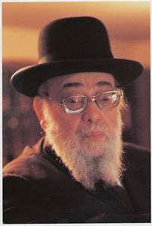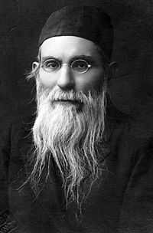
Rabbi Yaakov Yitzhak Ruderma/ and The Alter of Slabodka

Once, Rabbi Yaakov Yitzhak Ruderman, Rosh Yeshiva of Ner Yisrael in Baltimore, had to travel to Brooklyn to go to the wedding of a close student, but arrived two days early for meetings. While in Brooklyn, the young man who traveled with Rav Ruderman received a call from one of Rav Ruderman’s old classmates, who mentioned that he was also in town and asked if he could visit the Rav for a few minutes to catch up on old times. The Bachur told the man to come over, thinking a face from the past would ease Rav Ruderman’s many ailments.
When Rav Ruderman discovered the visiting person’s identity, he immediately put on his coat and told his attendant he’s going for a very long walk in the neighborhood. When the Rav returned, the young man wondered why the Rav knowingly missed the visitor.
“It was 50 years ago when Rav Nosson Tzvi Finkel (Alter of Slabodka) told me to stay away from that person because he would have a negative influence on me, so today I had no choice but to leave.”
Comment: We see that Moshe Rabbeinu added a Yud to Yehoshua’s name, before the latter was sent on a spy mission to the Holy Land. Moshe also prayed for Yehoshua. Why? Because even a short time around a bad influence can undo decades of working on oneself. If Yehoshua wasn’t immune, Rav Ruderman posited he, too, was vulnerable. How much more so do we, relative weaklings, have to limit our exposure with the immoral and depraved society around us? Praying for protection and being aware is a great start in this tough task.
Reprinted from last week’s email from Reb Mendel Berlin.

